SAMPLE LIGHTING, COLORS, TEXT

Sample A

Exhibition Title (Vinyl Lettering)

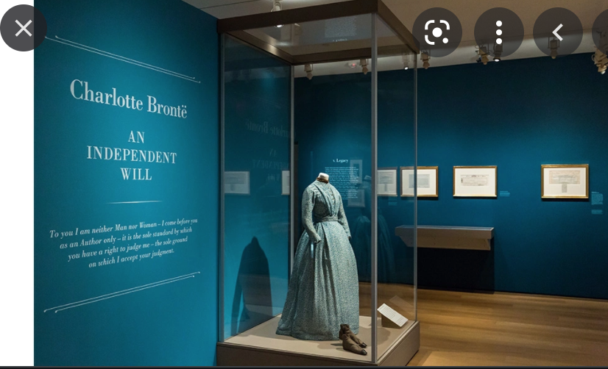

Sample B

Section Title

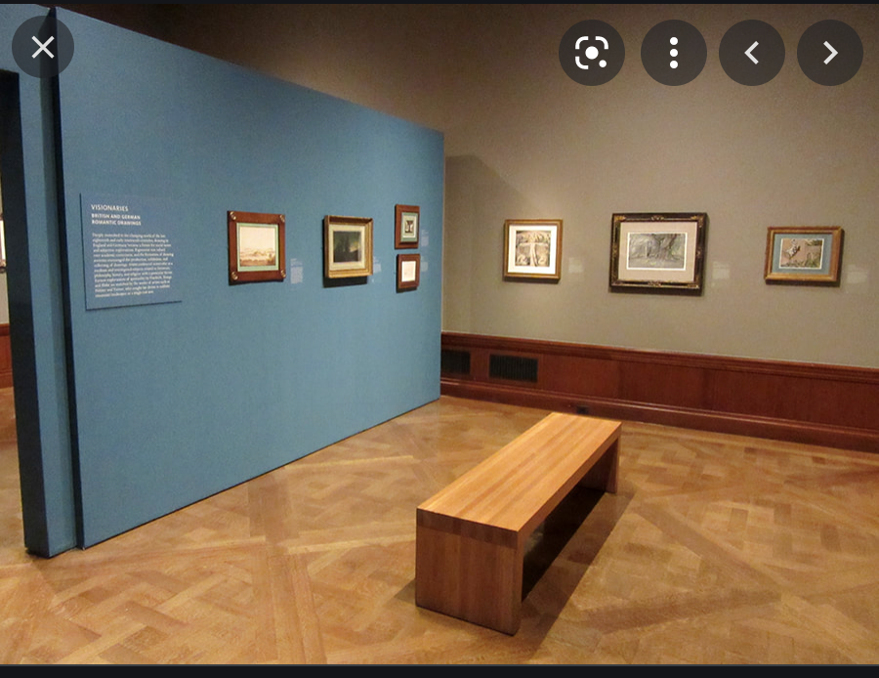

Sample C

Object Panels

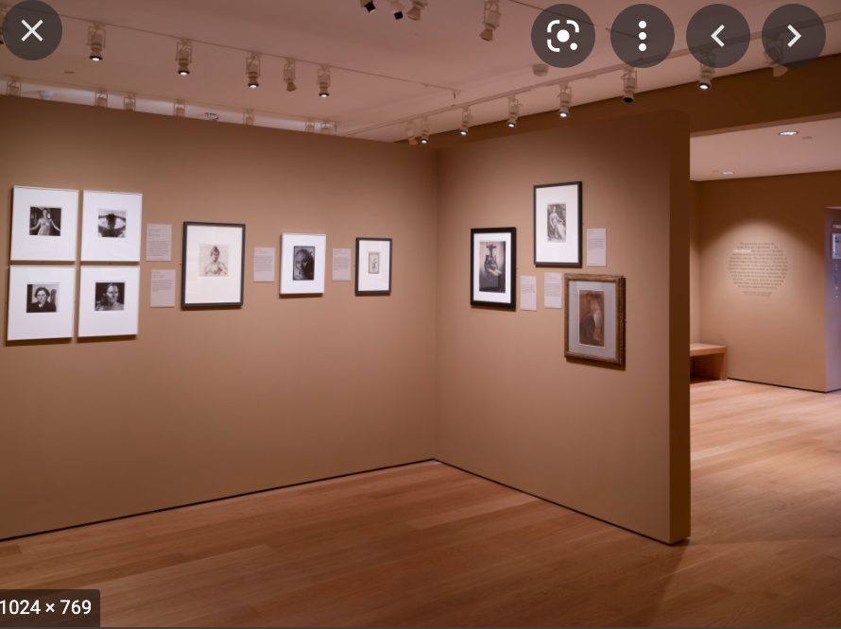

Sample D

Mounted TV Screens

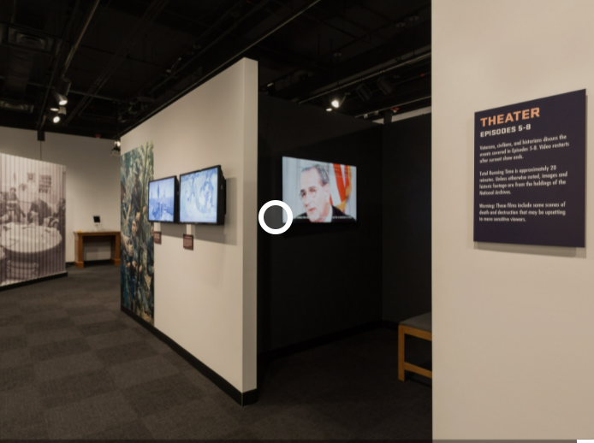

Sample E

Exhibit Bench

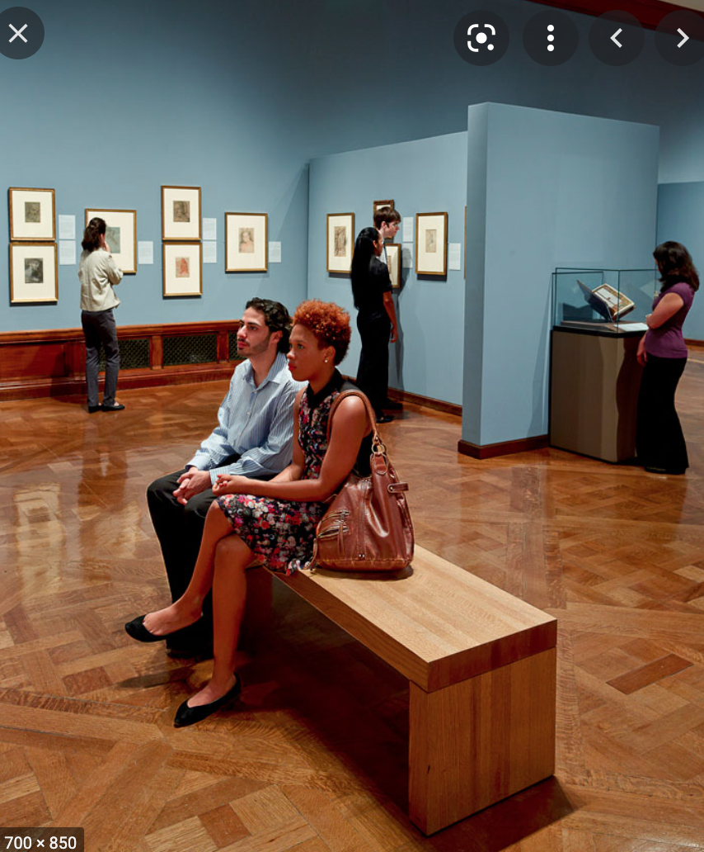

Sample F

Manuscript Exhibit Case

